 

**A Minor Project Report**

**on**

WATER LEAKAGE DETECTION SYSTEM WITH AUTOMATIC STOPPING MECHANISM

Submitted by

**ADHINI P V (927622BEE003)**

**AGILESH S (927622BEE005)**

**ARAVIND S (927622BEE006)**



**DEPARTMENT OF ELECTRICAL AND ELECTRONICS ENGINEERING**

**M.KUMARASAMY COLLEGE OF ENGINEERING**

(An Autonomous Institution Affiliated to Anna University, Chennai)

THALAVAPALAYAM, KARUR-6369113.

**MAY 2024**

I

**M.KUMARASAMY COLLEGE OF ENGINEERING**

(Autonomous Institution, Affiliated to Anna University, Chennai)

**BONAFIDE CERTIFICATE**

Certified that this Report titled **“WATER LEAKAGE DETECTION SYSTEM WITH AUTOMATIC STOPPING MECHANISM”** is the bonafide work of **ADHINI P V (927622BEE003), AGILESH S (927622BEE005**), **ARAVIND S (927622BEE006)** who

carried out the work during the academic year (2023-2024) under my supervision. Certified further that to the best of my knowledge the work reported herein does not form part of any other project report.

### SIGNATURE SIGNATURE

**SUPERVISOR HEAD OF THE DEPARTMENT**

Mrs.R.Indhumathi M.E., Dr.J.Uma M.E., Ph.D.,

Assistant Professor Professor & Head

Department of Electrical and Department of Electrical and

Electronics Engineering Electronics Engineering

M.Kumarasamy College of M.Kumarasamy College of

Engineering, Karur Engineering, Karur

Submitted for Minor Project II (18EEP202L) viva-voce Examination held at M.Kumarasamy College of Engineering,Karur-639113 on ………………..

II

**DECLARATION**

We affirm that the Minor Project II report titled **“WATER LEAKAGE DETECTION SYSTEM WITH AUTOMATIC STOPPING MECHANISM”** being submitted in partial fulfillment for the award of **Bachelor of Engineering in Electrical and Electronics** is the original work carried out by us.

|  |  |  |
| --- | --- | --- |
| **REG NO** | **STUDENT NAME** | **SIGNATURE** |
| **927622BEE003**  **927622BEE005**  **927622BEE006** | **ADHINI P V**  **AGILESH S ARAVIND S** | --------------------------  **------------------------**  **------------------------** |
|  | III |  |

# VISION AND MISSION OF THE INSTITUTION

**VISION**

* To emerge as a leader among the top institutions in the field of technical education

# MISSION

* Produce smart technocrats with empirical knowledge who can surmount the global Challenges.
* Create a diverse, fully-engaged, learner - centric campus environment to provide Quality education to the students.
* Maintain mutually beneficial partnerships with our alumni, industry, and Professional associations.

# DEPARTMENT OF ELECTRICAL AND ELECTRONICS ENGINEERING VISION

To produce smart and dynamic professionals with profound theoretical and practical knowledge comparable with the best in the field.

# MISSION

* Produce hi-tech professionals in the field of Electrical and Electronics Engineering by inculcating core knowledge.
* Produce highly competent professionals with thrust on research.
* Provide personalized training to the students for enriching their skills.

## PROGRAMME EDUCATIONAL OBJECTIVES(PEOs)

* **PEO1:** Graduates will have flourishing career in the core areas of Electrical Engineering and also allied disciplines.
* **PEO2:** Graduates will pursue higher studies and succeed in academic/research careers
* **PEO3:** Graduates will be a successful entrepreneur in creating jobs related to Electrical and Electronics Engineering /allied disciplines.
* **PEO4:** Graduates will practice ethics and have habit of continuous learning for their success in the chosen career.

IV

#### PROGRAMME OUTCOMES(POs)

After the successful completion of the B.E. Electrical and Electronics Engineering degree program, the students will be able to:

**PO1: Engineering Knowledge:** Apply the knowledge of mathematics, science, engineering fundamentals, and an engineering specialization to the solution of complex engineering problems.

**PO2: Problem Analysis:** Identify, formulate, review research literature, and analyze complex engineering problems reaching substantiated conclusions using first principles of mathematics, natural sciences, and engineering sciences.

**PO3: Design/Development of solutions:** Design solutions for Complex engineering problems and design system components or processes that meet the specified needs with appropriate consideration for the public health and safety, and the cultural, societal and environmental considerations.

**PO4: Conduct Investigations of complex problems:** Use research-based knowledge and research methods including design of experiments, analysis and interpretation of data, and synthesis of the information to provide valid conclusions.

**PO5: Modern Tool Usage:** Create, select, and apply appropriate techniques, resources, and modern engineering and IT tools including prediction and modeling to complex engineering activities with an understanding of the limitations.

**PO6:The Engineer and Society:** Apply reasoning in formed by the contextual knowledge to assess societal, health, safety, legal and cultural issues and the consequent responsibilities relevant to the professional engineering practice.

**PO7:Environment and Sustainability:** Understand the impact of the professional engineering solutions in societal and environmental contexts, and demonstrate the knowledge of, and need for sustainable development.

**PO8: Ethics:** Apply ethical principles and commit to professional ethics and responsibilities and norms of the engineering practice.

V

**PO9: Individual and Team work:** Function effectively as an individual, and as a member or leader in diverse teams, and in multi-disciplinary settings.

**PO10: Communication:** Communicate effectively on complex engineering activities with the engineering community and with society at large, such as, being able to comprehend and write effective reports and design documentation, make effective presentations, and give and receive clear instructions.

**PO11: Project Management and Finance:** Demonstrate knowledge and understanding of the engineering and management principles and apply these to one’s own work, as a member and leader in a team, to manage projects and in multi-disciplinary environments.

**PO12: Life-long learning:** Recognize the need for, and have the preparation and ability to engage in independent and life-long learning in the broadest context of technological change.

## PROGRAM SPECIFIC OUTCOMES(PSOs)

The following are the Program Specific Outcomes of Engineering Students:

* **PSO1:** Apply the basic concepts of mathematics and science to analyse and design circuits, controls, Electrical machines and drives to solve complex problems.
* **PSO2:** Apply relevant models, resources and emerging tools and techniques to providesolutions to power and energy related issues & challenges.
* **PSO3:** Design, Develop and implement methods and concepts to facilitate solutions for electrical and electronics engineering related real-world problems.

|  |  |
| --- | --- |
| **Abstract (Key Words)** | **Mapping of POs and PSOs** |
| Advanced water leak detection, Automatic Stopping mechanism, sends real-time alerts, user-friendliness | PO1, PO2, PO3, PO4, PO5, PO6, PO7, PO8, PO9, PO10, PO11, PO12  PSO1, PSO2, PSO3 |

VI

### [ACKNOWLEDGEMENT](https://www.google.com/search?rlz=1C1CHBD_enIN820IN820&q=ACKNOWLEDGEMENT&spell=1&sa=X&ved=0ahUKEwj99az1_ZXhAhVN63MBHRVODE4QkeECCCkoAA&cshid=1553265789884876)

Our sincere thanks to **Thiru.M.Kumarasamy, Founder and Dr.K.Ramakrishnan B.E, Chairman** of **M.Kumarasamy College of Engineering** for providing extra ordinary infrastructure, which helped us to complete the Minor project in time.

It is a great privilege for us to express our gratitude to our esteemed **Principal Dr.B.S.Murugan M.Tech., Ph.D.,** for providing us right ambiance for carrying out the project work.

We would like to thank our **Head of the Department Dr.J.Uma M.E., Ph.D., Department of Electrical and Electronics Engineering,** for her unwavering moral support throughout the evolution of the project.

We would like to express my deep gratitude to our Minor Project Guide **Mrs.R.Indhumathi M.E., Assistant Professor, Department of Electrical and Electronics Engineering,** for her constant encouragement, kind co-operation, valuable suggestions and support rendered in making our project a success.

We offer our wholehearted thanks to our Minor project coordinator **Mr.P.Maniraj M.E., Assistant Professor, Department of Electrical and Electronics Engineering,** for his constant encouragement, kind co- operation and valuable suggestions for making our project a success.

We are glad to thank all the **Faculty Members** of **Department of Electrical and Electronics Engineering**

for extending a warm helping hand and valuable suggestions throughout the project.

Words are boundless to thank **Our Parents and Friends** for their constant encouragement to complete this Minor project successfully.

VII

# TABLE OF CONTENTS

|  |  |  |
| --- | --- | --- |
| **CHAPTERNO** | **TITLE** | **PAGE NO** |
|  | **ABSTRACT** | 9 |
| **1** | **SURVEY FORM ANALYSIS** | 13 |
|  | 1.1 Name and Address of the Community | 13 |
|  | * 1. Problem Identification   2. Proposed Solution | 13  13 |
| **2** | **LITERATURE REVIEW** | 14 |
| **3** | **PROPOSED METHODOLOGY** | 16 |
|  | * 1. Block Diagram | 16 |
|  | 3.2 Description | 17 |
|  | 3.3 Project-Total cost | 18 |
| **4**  **5** | **RESULT AND DISCUSSION**  4.1 Hardware Component Description  4.2 Hardware Kit  4.3 Working Principle  **CONCLUSION**  **PROJECT IMPLEMENTATION GEO-TAG**  **PHOTO**  **PROJECT DEMONSTRATION VIDEO LINK** | 19  19  21  23  24  27  28 |
|  | **REFERENCES** | 29 |

VIII

**ABSTRACT**

The water leakage detection system with automatic stopping mechanism utilizes Arduino, a servo motor, a valve, and a water flow sensor to prevent water damage caused by leaks. The system operates by continuously monitoring the flow of water using the water flow sensor. When an abnormal flow rate is detected, indicating a potential leak, the Arduino triggers the servo motor to actuate the valve, shutting off the water supply to prevent further leakage. The Arduino is programmed to constantly monitor the output of the water flow sensor. If the sensor detects a flow rate exceeding a predefined threshold or experiences a sudden change in flow rate, the Arduino interprets this as a potential leak. In response, it sends a signal to the servo motor to rotate, closing the valve and cutting off the water supply. This system offers an automated solution for detecting and stopping water leaks, providing timely intervention to mitigate water damage. Additionally, the use of Arduino allows for flexibility in programming and customization, enabling adaptation to various plumbing setups and environmental conditions.

9

**SURVEY FORM**

**Department of Electrical and Electronics Engineering**

**Academic Year (2023-2024)**

**18EEP202L – Minor Project II**

**Problem Identification – Survey Form**

1. **Name and Address of the community:**

**2. Age Group**

* 1. **Less than 10 Years**
  2. **10 years to 20 Years**
  3. **21 years to 35 Years**
  4. **36 Years to 50 Years**
  5. **More than 50 Years**

**3. Discussion:**

* 1. **What?** *(Define the Problem)*
  2. **Why?** *(Reason for the Problem occurrence)*
  3. **When?** *(When the problem began or first noticed)*
  4. **Where?** *(Place of the problem’s first occurrence or sighting)*

10

* 1. **Who?** *(The person or thing that the problem affects)*
  2. **How?** *(The sequence of events that resulted in the problem)*

**Signature of the Respondent**

* 1. **Which?** *(People have attempted to solve the issue)*
  2. Does the problem appear to have only one possible solution?

**4. Work Plan of the project**

**5. Final Solution**

**Signature of the Surveyor**

11

**SAMPLE PICTURES**

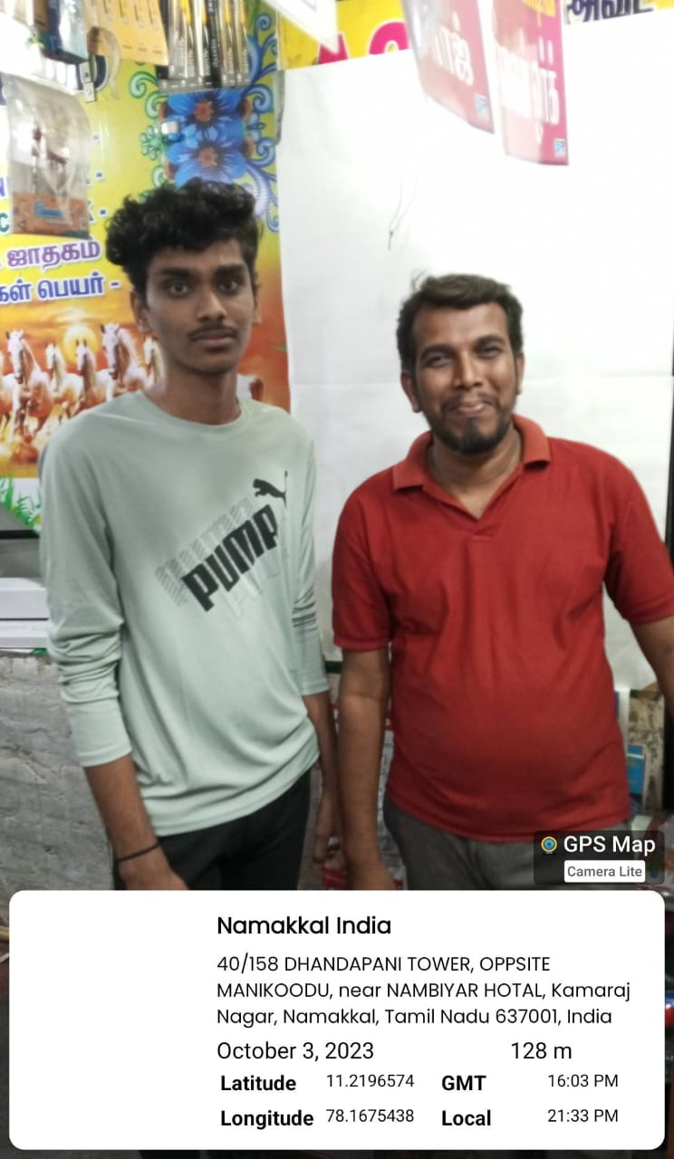

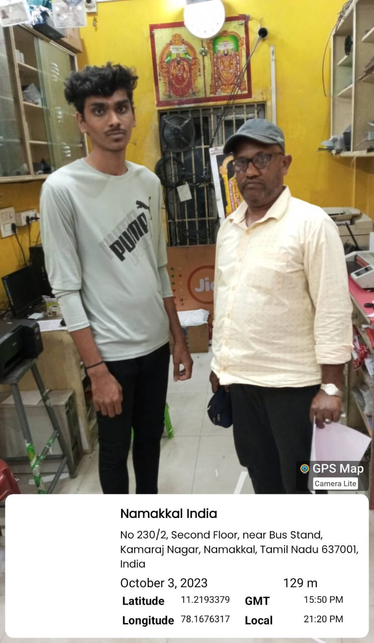

12

# CHAPTER 1

# SURVEY FORM ANALYSIS

* 1. **NAME AND ADDRESS OF THE COMMUNITY:**

S. Priya Dharshini, 136C, Thalavapalaiyam, Karur.

S. Indhira, 108C, Thalavapalaiyam, Karur.

R. Yagesh Raj, 4/394, Narasingan Street, Cuddalore.

U. Uthayan, 2/259, Kolayanur, Ariyalur. Kumar,2/13, Mariamman Street, Namakkal. Dhandapani, 5/467, Thuraiyur road, Namakkal.

# 1.2 PROBLEM IDENTIFICATION:

Unable to find water leakage occur in the underground.

Large amount of water is wasted due to slower process of finding the area of water leakage. Older pipelines in buildings are getting damaged and the water gets leaked from the pipe.

### 1.3 PROPOSED SOLUTION:

Using sensors to find the water leakage occurs in the underground.

The project provides automatic instant valve closing system after finding the water leakage which

Reduced wastage water.

13

# CHAPTER 2

# LITERATURE REVIEW

**Paper 1: Flow Sensors in Industrial Processes: Enhancing Performance and Reliability Inference:** Highlighting industrial applications, this review explores how flow sensors contribute to enhancing the performance and reliability of various industrial processes, offering insights into their diverse roles.

## Paper 2: Pressure Sensor Applications in Water Leakage Detection Systems: A Comprehensive Literature Review

**Inference**: This literature review critically examines the role of pressure sensors in water leakage detection systems, exploring the technological advancements, methodologies, and challenges associated with their implementation. It provides valuable insights into how pressure sensor technologies contribute to the effectiveness and reliability of water leakage detection, offering a foundation for further research and development in this domain.

## Paper 3: Sensing the Drops: A Synoptic Analysis of Sensor Technologies in Water Leakage Detection

**Inference:** Examining a spectrum of sensor technologies, this literature review elucidates their strengths and limitations in water leakage detection systems, paving the way for informed decisions in selecting appropriate sensors for specific environmental conditions

## Paper 4: Geared Motor Applications in Manual Valve Actuation: A Comprehensive Literature Review

**Inference:** This literature review explores the diverse applications of geared motors in manually operated valve systems, providing insights into their efficiency, reliability, and adaptability across various industrial and commercial settings.

14

## Paper 5: Arduino-Based Water Leakage Detection Systems: An In-Depth Review

**Inference:** This literature review explores the diverse applications and innovations associated with Arduino-based water leakage detection systems, shedding light on the versatility and effectiveness of Arduino micro controllers in addressing water infrastructure challenges.

15

# CHAPTER 3

# PROPOSED METHODOLOGY

**3.1 BLOCK DIAGRAM**

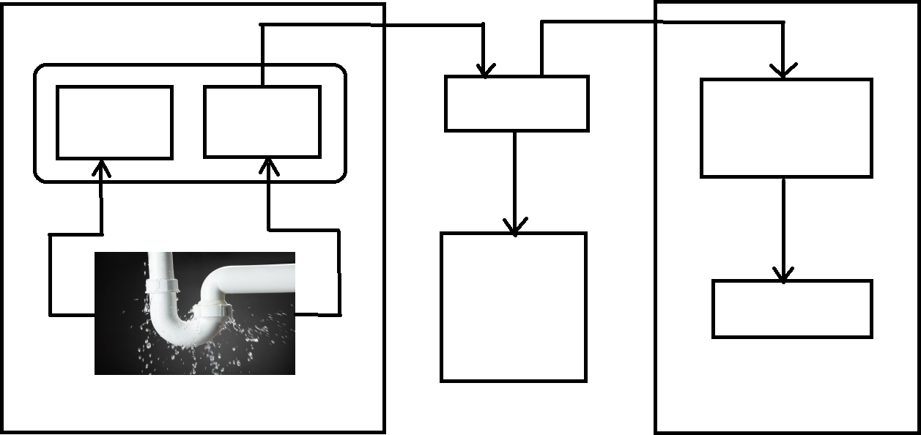

**FLOW**

**SENSOR**

**PRESSURE**

**SENSOR**

**ARDUINO**

**GEARED**

**MOTOR**

**BATTERY OR**

**POWER**

**SUPPLY**

**VALVE**

**Fig 3.1 Block Diagram**

16

# 3.2 DESCRIPTION

The water leakage detection system with automatic stopping mechanism is designed for detecting the water leakage using two sensors. There are flow sensor and pressure sensor. It will detect the leakage and send the signal to Arduino micro controller. Arduino did not able to understand the signal form the sensor so we use Analog to Digital converter here for understand the signal to Arduino. Main purpose of the Arduino to control the whole circuit. Arduino act as a switch to control the supply for Geard motor. When Arduino receives the signal from the sensors it gives the supply to the Geard Motor. When the signals cut of from the sensor it cuts the supply. We did not able to rotate the shaft of the Geard motor manually. When we giving the supply the Geard motor the shaft starts to rotate. A manual valve mechanically coupled to the Geard motor shaft. When the Geard motor receives the supply the shaft starts to rotate a manual valve also rotates due to coupling with shaft. Due to the rotation of manual valve the shaft closes the valve.

In recent days we using some meter to detect the water leakage in the underground. Before the detection of leakage it takes some time. During the time period, there will be some amount of leakage of water by using “Water leakage detection system with automatic stopping mechanism” to detect the water leakage instantly. So we able to save the leakage of water.

By using “Water leakage detection system with automatic stopping mechanism” we able to detect the underground water leakage in huge Metro Politian, Industrial, City areas etc…

17

# PROJECT – TOTAL COST

|  |  |  |  |
| --- | --- | --- | --- |
| **S.NO** | **COMPONENT DESCRIPTION** | **QUANTITY** | **COST** |
| 01 | **BATTERY** | 3 | 600 |
| 02 | **MANUAL VALVE** | 1 | 283 |
| 03 | **FLOW SENSOR** | 1 | 550 |
| 04 | **ARDUINO** | 1 | 810 |
| 05 | **SERVO MOTOR** | 1 | 250 |
|  |  | TOTAL | 2493 |

**Table 3.1 Project-Total cost**

18

# CHAPTER 4

# RESULT AND DISCUSSION

# 4.1 HARDWARE COMPONENTS DESCRIPTION

# 

# ARDUINO BOARD:

# The Arduino microcontroller acts as the brain of the system. It processes signals from the water flow sensor, executes the logic to detect leaks, and controls the servo motor to operate the valve. The Arduino is programmable, allowing for customization of thresholds and responses based on specific requirements.

# 

# Fig 4.1 ARDUINO BOARD

# WATER FLOW SENSOR:

# The water flow sensor is responsible for measuring the flow rate of water through the pipe. It typically consists of a rotor, which spins as water flows through it, and a Hall effect sensor, which generates electrical pulses corresponding to the flow rate. The Arduino reads these pulses to determine the current water flow rate.

# 

# Fig 4.2 WATER FLOW SENSOR

# 19

# VALVE:

# The valve is a mechanical device that controls the flow of water in the system. It can be either normally open or normally closed and is operated by the servo motor. When a leak is detected, the Arduino signals the servo motor to adjust the valve position, stopping the flow of water to prevent damage.

# 

# Fig 4.3 VALVE

# SERVO MOTOR:

# The servo motor is used to actuate the valve based on the signals from the Arduino. Servos are precise and can be controlled to rotate to specific angles, making them ideal for opening or closing a valve.

# 

# Fig 4.4 SERVO MOTOR

# 20

# 4.2 HARDWARE KIT

# 

# Fig 4.5 (a) Output model 1

# The water leakage detection system uses a water flow sensor to continuously monitor flow rates. When the Arduino detects abnormal flow indicating a leak, it signals the servo motor to close the valve, stopping the water supply. This automated response prevents further leakage and potential damage.

# 21

# 

# Fig 4.5 (b) Output Model 2

# 22

# 4.3 WORKING PRINCIPLE

# 

# A water leakage detection system with an automatic stopping mechanism is designed to prevent water damage by promptly identifying leaks and shutting off the water supply. This system typically consists of sensors strategically placed in areas prone to leaks, such as under sinks or near appliances. When these sensors detect water, they send a signal to a control unit. The control unit then activates a valve connected to the main water supply, cutting off the flow of water to the affected area. This swift response helps mitigate potential damage and reduces water wastage. Creating a water leakage detection system with an automatic stopping mechanism using Arduino components, servo motor, valve, and flow sensor involves several steps. First, assemble the components including the Arduino board, a servo motor, a solenoid valve, and a flow sensor. Place the flow sensor in the water pipeline to monitor the flow rate and position moisture sensors in areas prone to leaks. Write code for the Arduino to read data from the flow sensor and moisture sensors. If the sensors detect water or an abnormal flow rate, the Arduino triggers the servo motor to actuate, closing the valve and stopping the water flow. Optionally, integrate a notification system to alert the user about the leak and valve closure. Test the system thoroughly to ensure proper functionality and calibrate the sensors for accurate detection. Install the system in areas where leaks are likely to occur and perform regular maintenance to ensure its continued effectiveness.

# 23

# CHAPTER 5

**CONCLUSION**

The Water Leakage Detection System with Automatic Stopping Mechanism has demonstrated its effectiveness in addressing the critical issue of water leakage. This project successfully integrated sensitive leak detection sensors, automatic shut-off valves, and user notification systems to provide a comprehensive solution. The early detection capability of the sensors ensures that leaks are identified at their inception, significantly reducing water wastage and preventing extensive property damage. The automatic shut-off mechanism is a key feature, immediately stopping water flow when a leak is detected, thus mitigating the potential for severe damage. User notifications, delivered via mobile alerts, ensure that users are promptly informed of any issues, allowing for quick manual intervention if necessary.

This system is not only beneficial for individual homeowners but also has significant implications for larger commercial properties, highlighting its scalability and customization potential.The environmental impact of this system is substantial, contributing to water conservation efforts by preventing prolonged leaks. This is particularly important in areas with water scarcity, making the system both environmentally and economically advantageous. Despite these successes, the project faced challenges, such as integrating the system with existing smart home technologies and improving sensor durability and accuracy. Future enhancements could include the use of machine learning to predict leaks based on water usage patterns, adding a preventive dimension to the system. Overall, the Water Leakage Detection System with Automatic Stopping Mechanism represents a significant advancement in home automation and water management.

24

**POST IMPLEMENTATION SURVEY FORM**

**Department of Electrical and Electronics Engineering 18EEP202L – Minor Project II**

**Problem Identification – Survey Form**

* + 1. **Name and Address of the community**:
    2. **Age Group**
       1. **Less than 10 Years**
       2. **10 years to 20 Years**
       3. **21 years to 35 Years**
       4. **36 Years to 50 Years**
       5. **More than 50 Years**
    3. **Discussion:**
       1. **What**? (Define the Problem)

1. **Why?** (Reason for the Problem occurrence)
2. **When?** (When the problem began or first noticed)
3. **Where?** (Place of the problem‘s first occurrence or sighting)
4. **Who?** (The person or thing that the problem affects)

25

1. **How?** (The sequence of events that resulted in the problem)

**Signature of the respondent**

1. **Which?** (People have attempted to solve the issue)
2. **Does the problem appear to have only one possible solution?**
3. **Work Plan of the project**
4. **Final Solution**

**Signature of the surveyor**

26

**PROJECT IMPLEMENTATION** – **GEOTAG PHOTO**

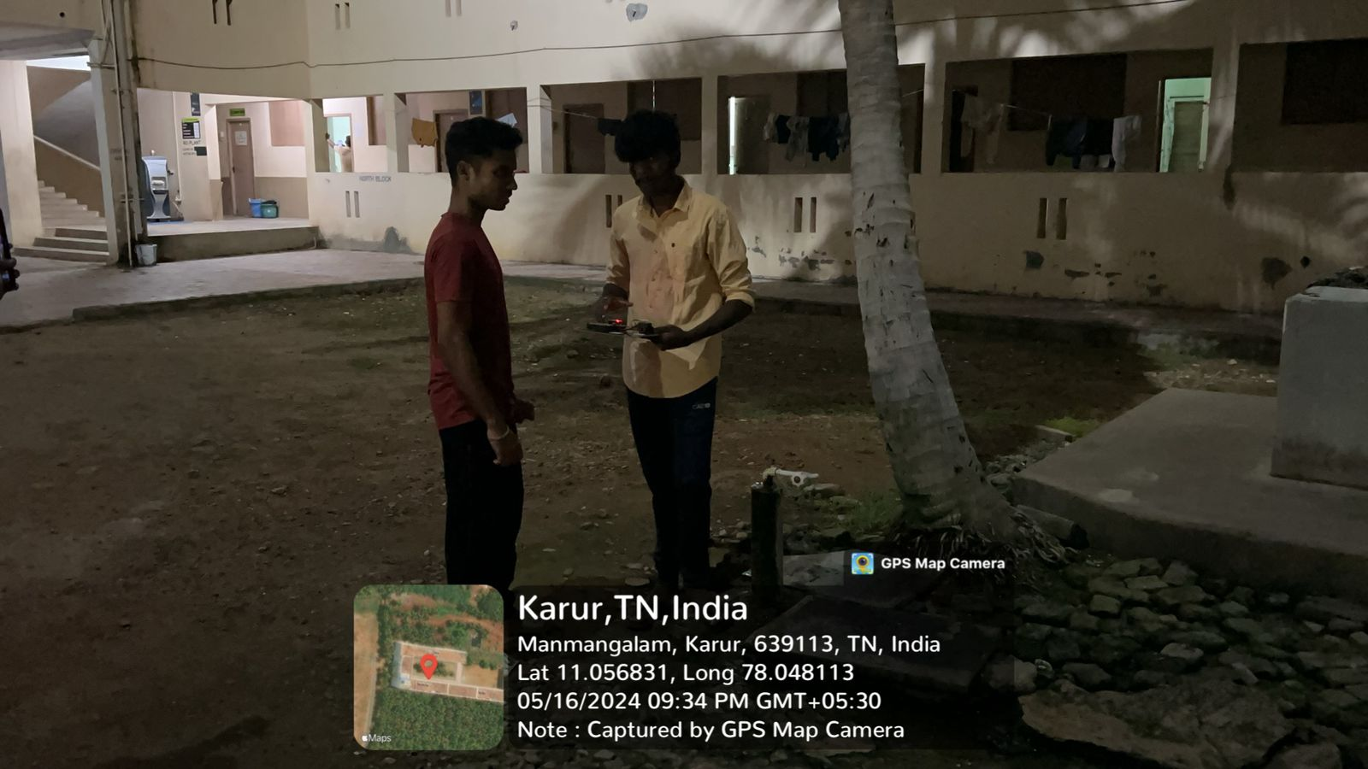

**Fig (a) Implementation picture 1**

27

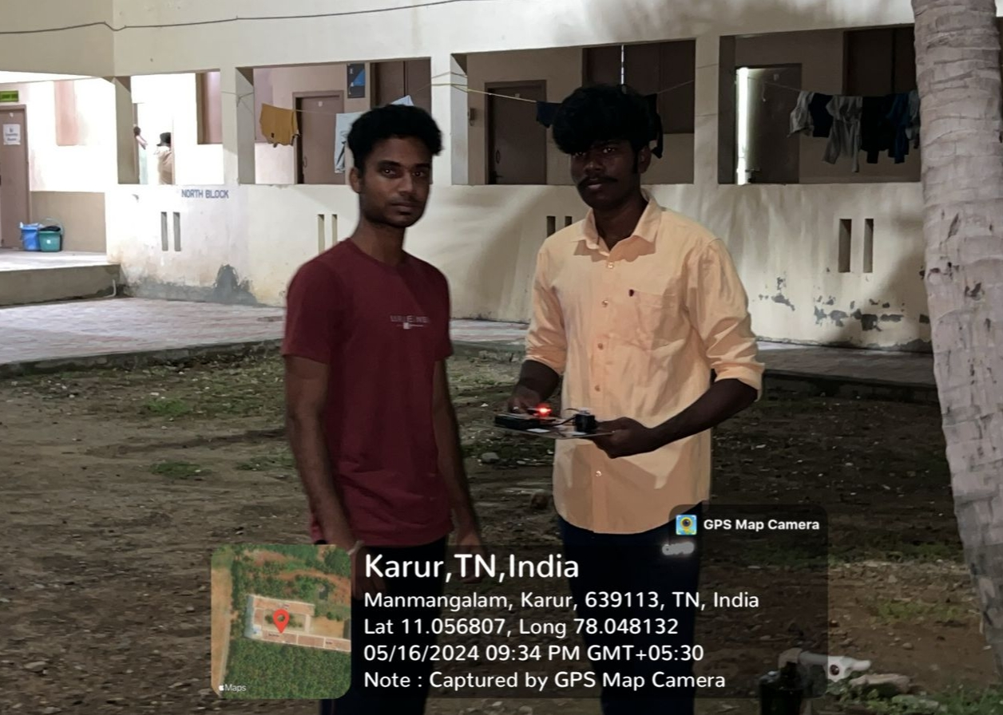

**Fig (b) Implementation picture 2**

**PROJECT DEMONSTRATION VIDEO LINK**

[**https://drive.google.com/file/d/14GsK9mCB0cMo4A_k978n8usNilGC8zaH/view?usp=drivesdk**](https://drive.google.com/file/d/14GsK9mCB0cMo4A_k978n8usNilGC8zaH/view?usp=drivesdk)

28

# REFERENCES

Title: "A Water Leakage Detection and Prevention System" Authors: A. Ashwini, P. Harini, R. Hemalatha

Published in: International Journal of Scientific Research in Computer Science, Engineering and Information Technology (IJSRCSEIT), September 2018.

Link

Title: "Arduino-based water leakage detection and prevention system using Raspberry Pi" Authors: Y.-T. Jeong, H.-S. Cho, M.-S. Moon, Y.-S. Joo

Published in: Journal of Ambient Intelligence and Humanized Computing, November 2019 Leak Detection: Technology and Implementation

By

Stuart Hamilton; Bambos Charalambous IWA Publishing

### DOI:

<https://doi.org/10.2166/9781789060850>

#### ISBN electronic:

9781789060850

#### Publication date:

January 2020

29